

**UNIVERSIDAD TECNOLÓGICA DE**

**SAN LUIS RIO COLORADO**

**PRACTICA 4**

**MTRO. RICARDO ALEJANDRO SOTO MORALES**

**AUTOR: VICTOR MANUEL GALVAN COVARRUBIAS**

San Luis Rio Colorado, Sonora Julio, 2020

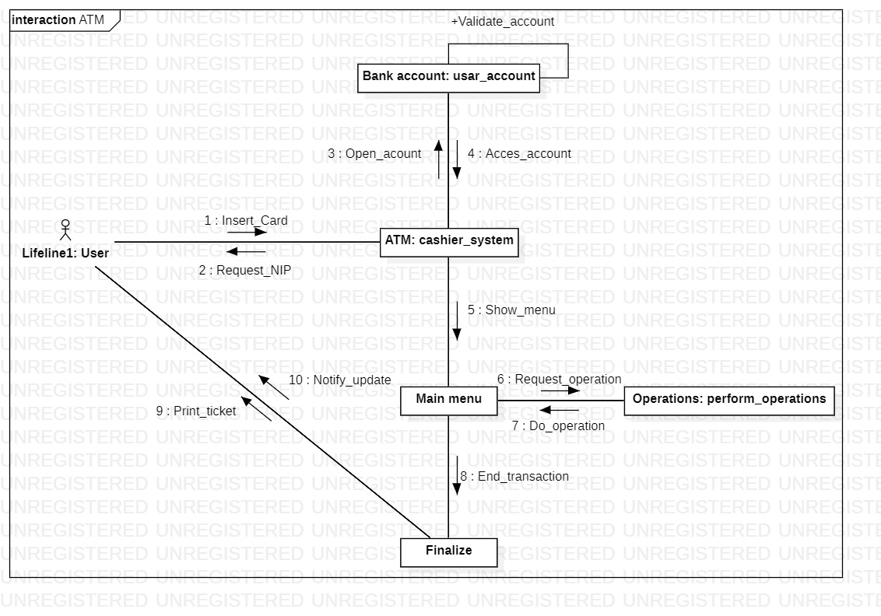

Illustration 1: Collaboration diagram corresponding to the service of an ATM.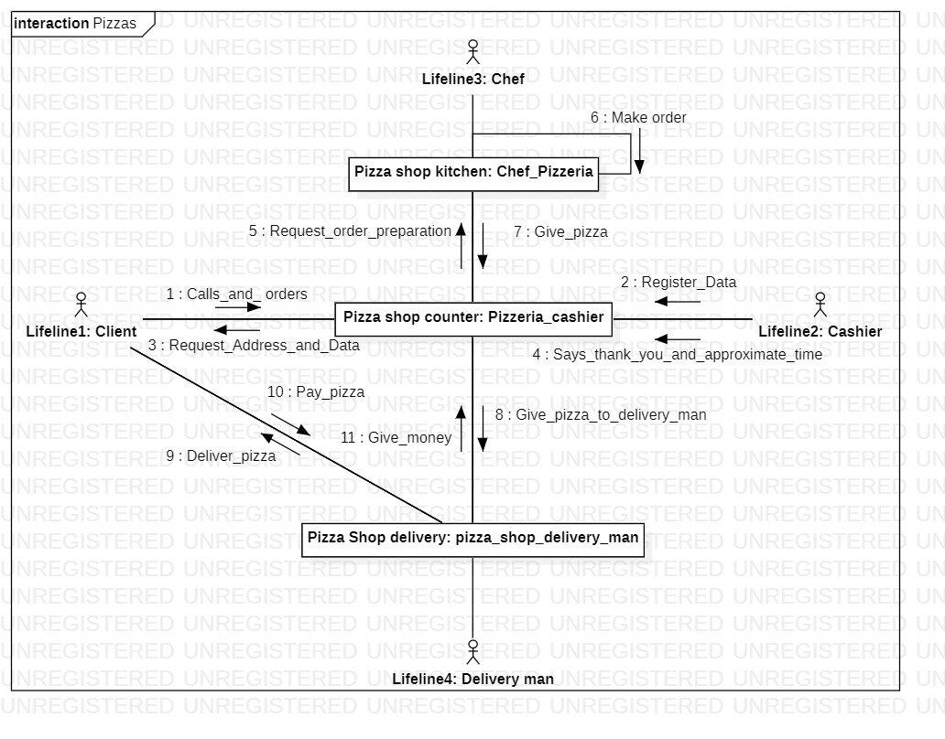

Illustration 2: Collaboration diagram corresponding to the pizzeria sales system.

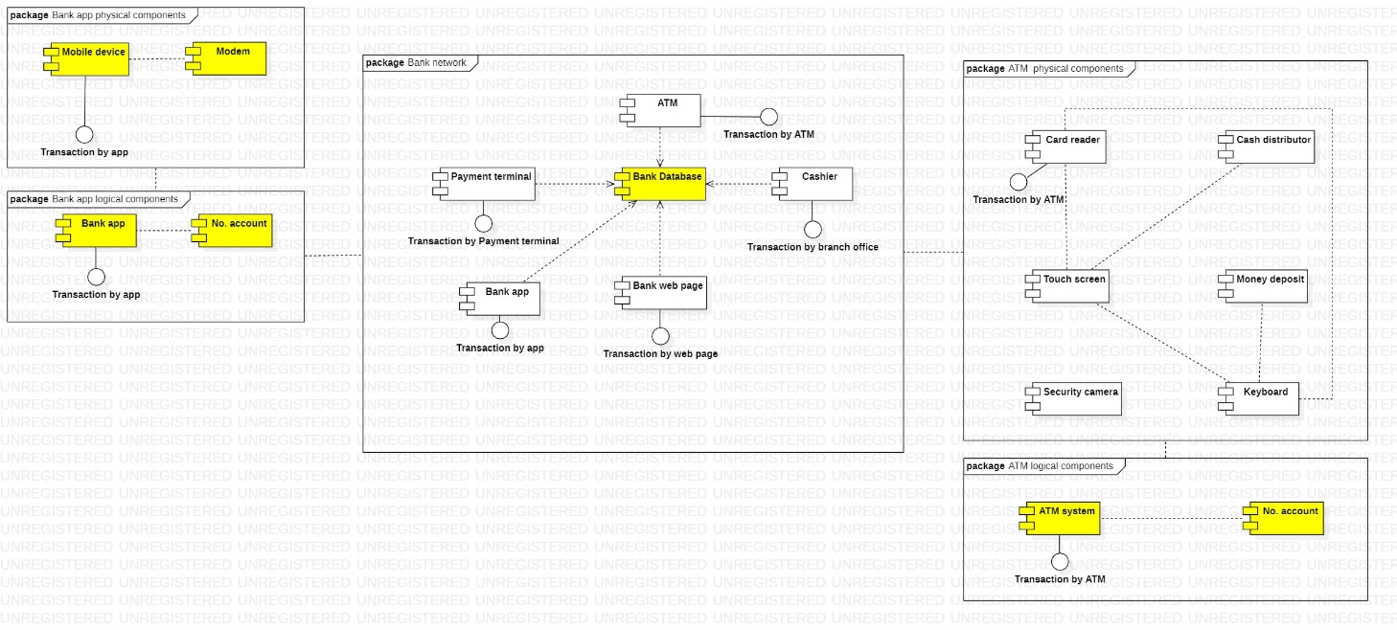

Illustration 3: Components diagram corresponding to a Bank network.

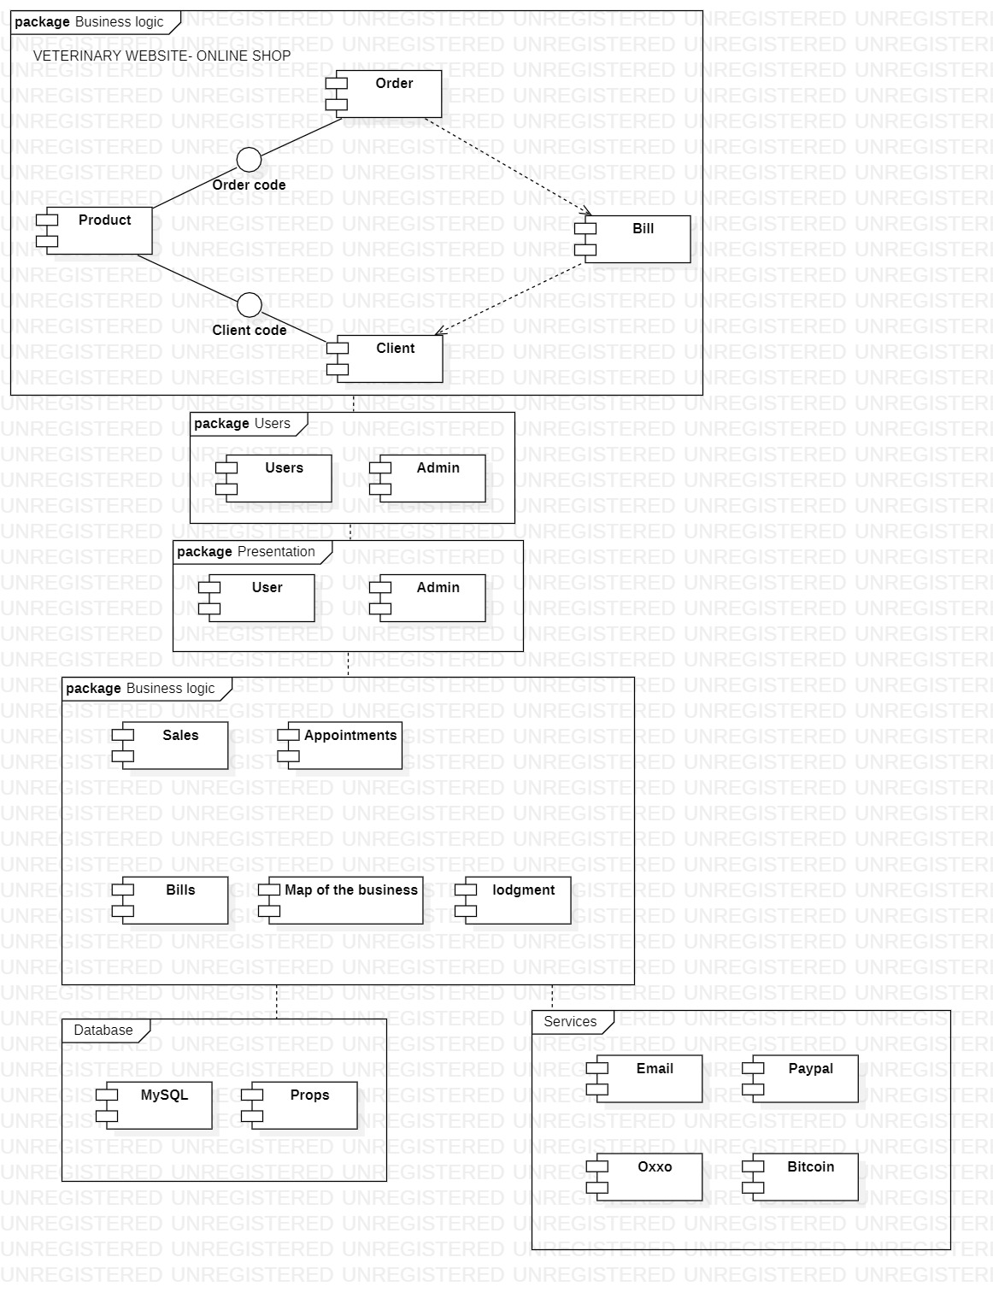

Illustration 4: Components diagram corresponding to a Web page.

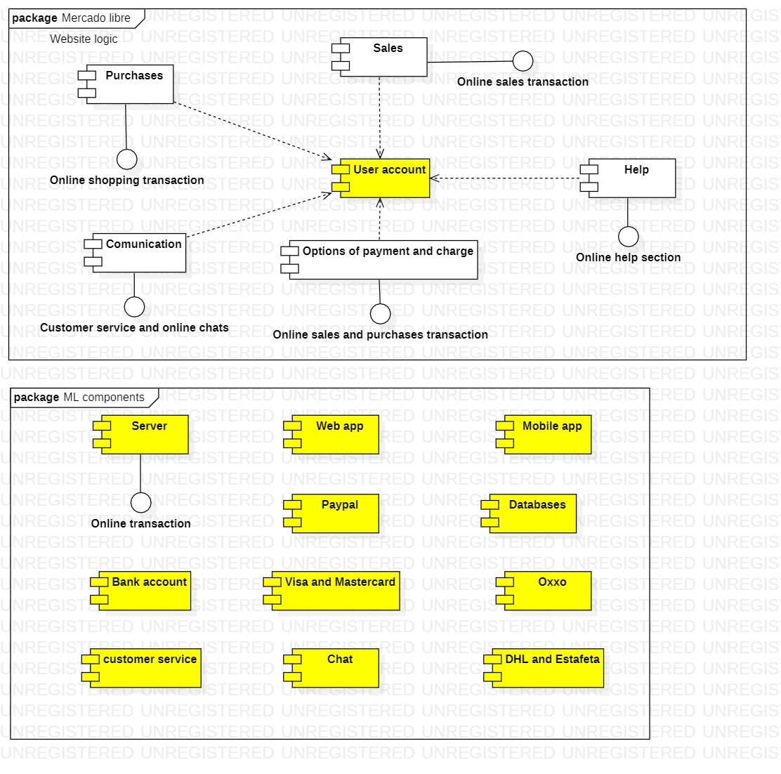

Illustration 5: Components diagram corresponding to Mercado Libre.

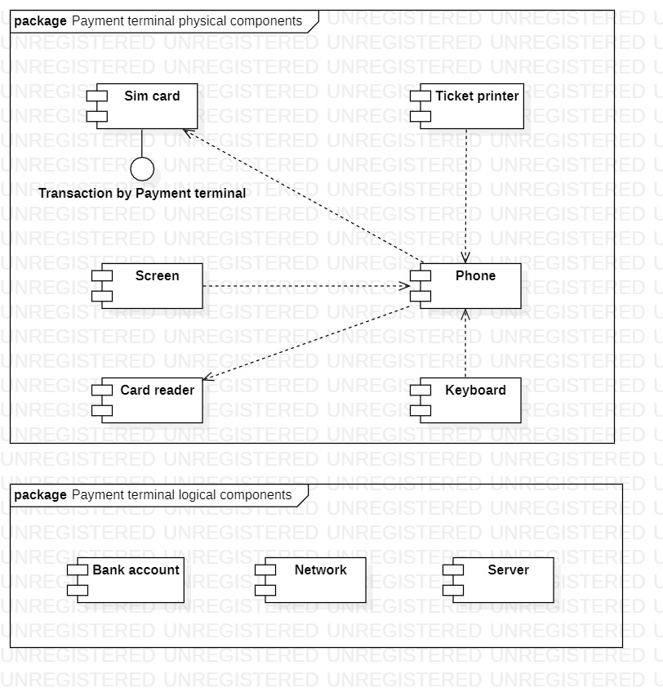

Illustration 6: Components diagram corresponding to a Payment terminal.

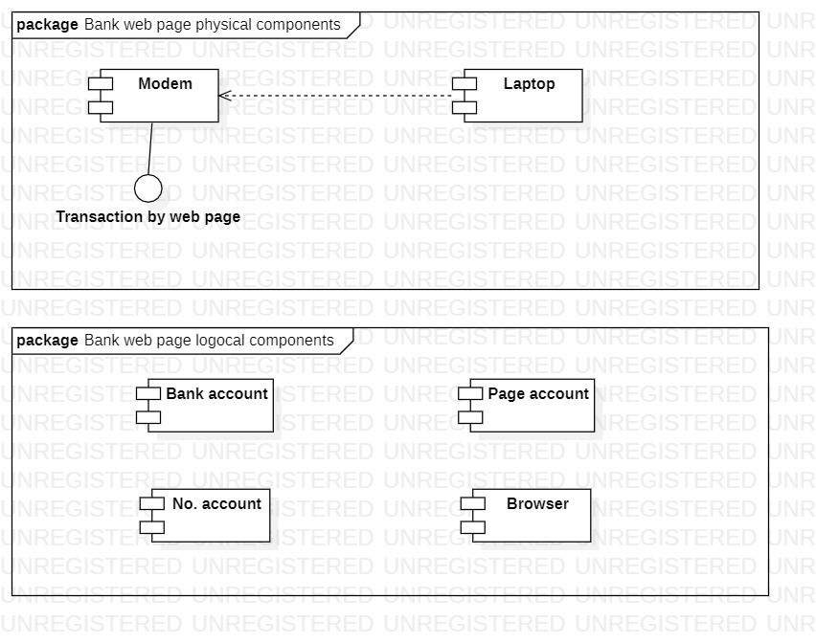

Illustration 7: Components diagram corresponding to a Bank web page.

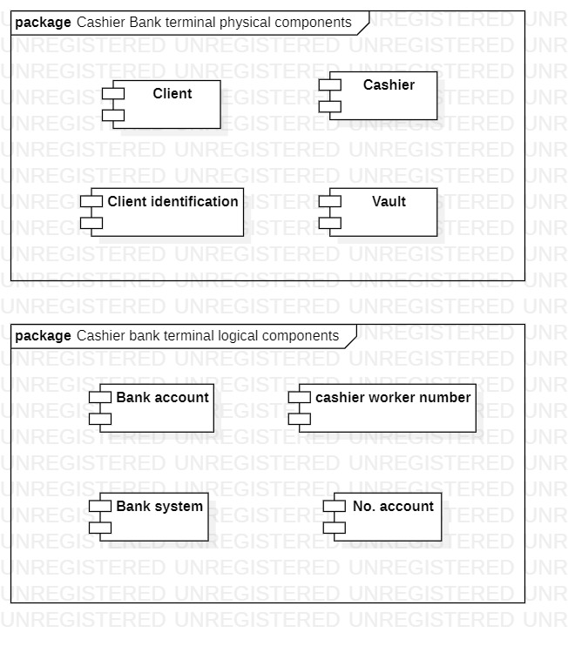

Illustration 8: Components diagram corresponding to a Cashier bank terminal.

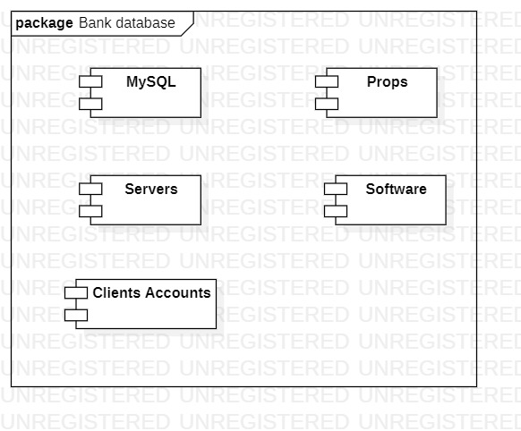

Illustration 9: Components diagram corresponding to a Bank database.